**Psuc Lab Assignment**

**Lab 6:**

**Q1**) Find whether a given matrix is symmetric or not.

**Code**:

#include<stdio.h>

int main()

{

int m,n,a[10][10];

int i,j;

printf("Enter the rows and coloumns\n");

scanf("%d %d",&m,&n);

if (m!=n)

printf("Its not a square matrix");

else

{

printf("Enter the elements\n");

for(i=0;i<m;i++)

{

for(j=0;j<n;j++)

scanf("%d",&a[i][j]);

}

printf("The given matrix is: \n");

for(i=0;i<m;i++)

{

for(j=0;j<n;j++)

printf("%d\t",a[i][j]);

printf("\n");

}

for(i=0;i<m;i++)

{

for(j=0;j<n;j++)

{

if (a[i][j]!=a[j][i])

{

printf("Matrix is Not Symmetric\n");

exit(0);

}

}

}

printf("Matrix is Symmetric\n");

printf("My name is Saksham");

}

return 0;

}

**Output**:

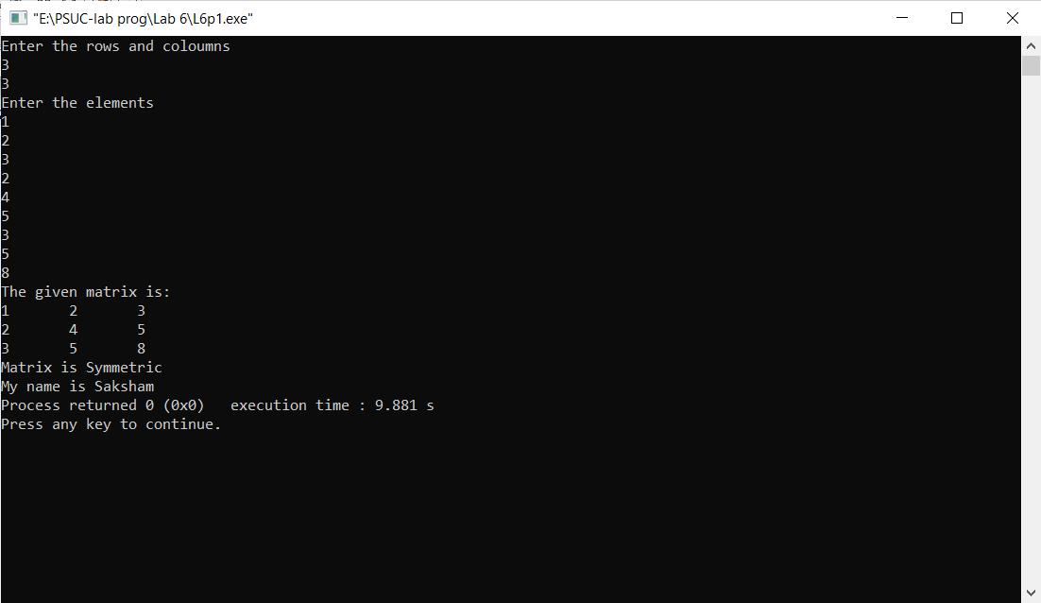

**Q2**) Find the trace and norm of a given square matrix.

**Code**:

#include<stdio.h>

#include<math.h>

int main()

{

int m,n,a[10][10],trace,norm,sum;

int i,j;

printf("Enter the number of rows and coloumns\n");

scanf("%d %d",&m,&n);

if(m!=n)

printf("Not a square matrix , trace and norm cant be found\n");

else

{

printf("Enter the elements\n");

for(i=0;i<m;i++)

{

for(j=0;j<n;j++)

scanf("%d",&a[i][j]);

}

printf("The Matrix is:\n");

for(i=0;i<m;i++)

{

for(j=0;j<n;j++)

printf("%d\t",a[i][j]);

printf("\n");

}

for(i=0;i<m;i++)

trace=trace+a[i][i];

for(i=0;i<m;i++)

{

for(j=0;j<n;j++)

sum=sum+a[i][j]*a[i][j];

}

norm = sqrt(sum);

printf("The trace of the matrix is: %d\n",trace);

printf("The norm of the matrix is: %d\n",norm); //gives the rounded product

}

printf("My name is Saksham");

return 0;

}

**Output**:

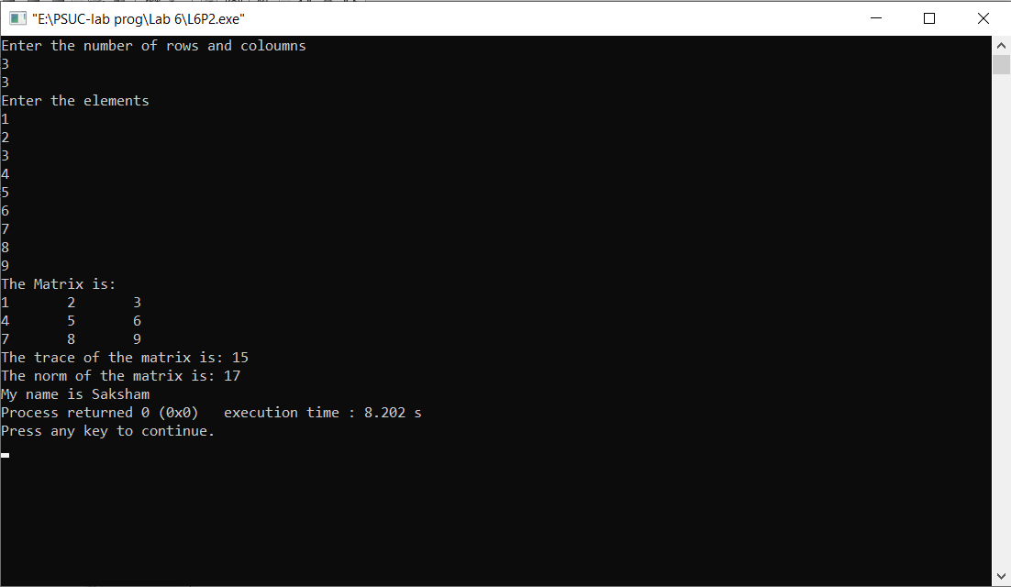

**Q3**) Perform matrix multiplication

**Code**:

#include <stdlib.h>

int main()

{

int i, j,k, m, n, p, q;

int a[10][10], b[10][10],c[10][10];

printf("Enter dimension for a\n");

scanf("%d %d",&m,&n);

printf("\n enter dimension for b\n");

scanf("%d %d", &p,&q);

if(n!=p)

{

printf("Not multiplicable");

}

else

{

printf("Enter elements for a\n");

for (i=0;i<m;i++)

{

for (j=0;j<n;j++)

scanf("%d",&a[i][j]);

}

printf("Enter elements for b\n");

for (i=0;i<p;i++)

{

for (j=0;j<q;j++)

scanf("%d",&b[i][j]);

}

for (i=0;i<m;i++)

{

for (j=0;j<q;j++)

{

c[i][j]=0;

for(k=0;k<n;k++)

c[i][j]=c[i][j]+a[i][k]*b[k][j];

}

}

printf("The multiplied matrix is: \n");

for(i=0;i<m;i++)

{

for(j=0;j<n;j++)

printf("%d\t",c[i][j]);

printf("\n");

}

}

printf("My name is Saksham");

return 0;

}

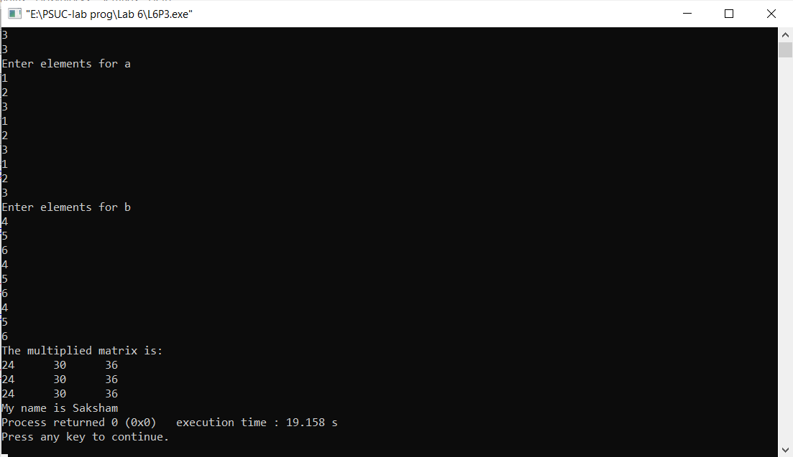Output:

**Q4**) To interchange the primary and secondary diagonal elements in the given Matrix.

#include<stdio.h>

int main()

{

int m,n,temp,a[10][10];

int i,j;

printf("Enter the dimensions of matrix\n");

scanf("%d %d",&m,&n);

if(m!=n)

{

printf("Matrix is not symmetric\n");

}

else

{

printf("Enter the elements of the matrix: \n");

for(i=0;i<m;i++)

{

for(j=0;j<n;j++)

scanf("%d",&a[i][j]);

}

printf("The original Matrix is:\n");

for(i=0;i<m;i++)

{

for(j=0;j<n;j++)

printf("%d\t",a[i][j]);

printf("\n");

}

for(i=0;i<m;i++)

{

for(j=0;j<n;j++)

{

if(i==j)

{

temp = a[i][j];

a[i][j]=a[i][n-i-1];

a[i][n-i-1]=temp;

}

}

}

printf("The Updated Matrix is: \n");

for(i=0;i<m;i++)

{

for(j=0;j<n;j++)

printf("%d\t",a[i][j]);

printf("\n");

}

}

printf("My name is Saksham");

return 0;

}

Output:

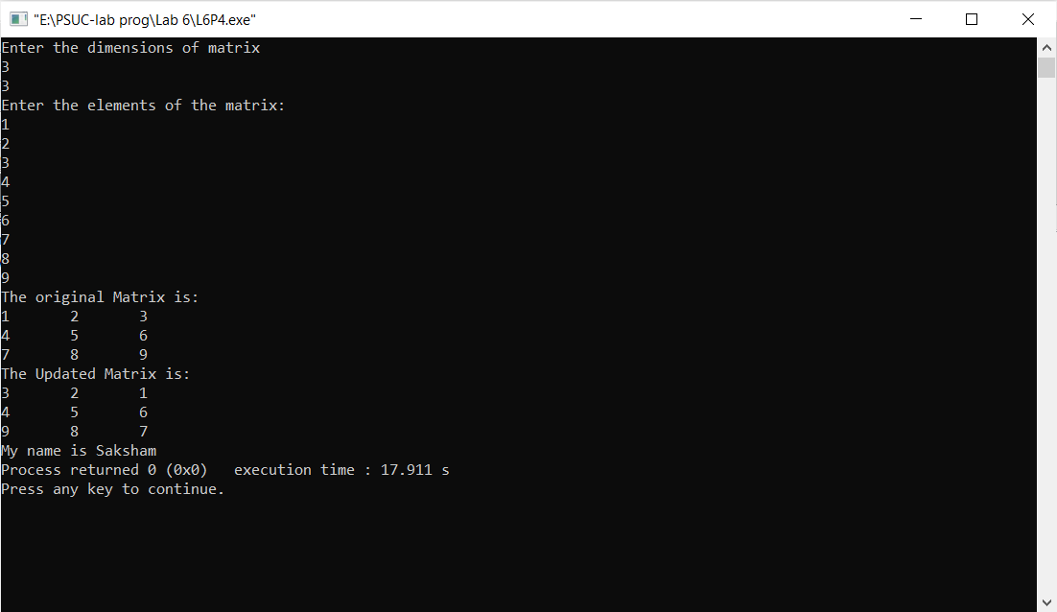

Q5) Interchange any two Rows & Columns in the given Matrix.

**Code**:

#include<stdio.h>

int main()

{

int m,n,a[10][10],temp,r1,r2,c1,c2;

int i,j;

printf("Enter the dimensions of the matrix: \n");

scanf("%d %d",&m,&n);

printf("Enter the elements of the matrix\n");

for(i=0;i<m;i++)

{

for(j=0;j<n;j++)

scanf("%d",&a[i][j]);

}

printf("The original matrix is \n");

for(i=0;i<m;i++)

{

for(j=0;j<n;j++)

printf("%d\t",a[i][j]);

printf("\n");

}

printf("\nEnter the rows to exchange:\n");

scanf("%d %d",&r1,&r2);

for(j=0;j<n;j++)

{ temp=a[r1-1][j];

a[r1-1][j]=a[r2-1][j];

a[r2-1][j]=temp;

}

printf("The updated matrix is: \n");

for(i=0;i<m;i++)

{

for(j=0;j<n;j++)

printf("%d\t",a[i][j]);

printf("\n");

}

printf("\nEnter the coloumns to exchange:\n");

scanf("%d %d",&c1,&c2);

for(i=0;i<m;i++)

{ temp=a[i][c1-1];

a[i][c1-1]=a[i][c2-1];

a[i][c2-1]=temp;

}

printf("The updated matrix is: \n");

for(i=0;i<m;i++)

{

for(j=0;j<n;j++)

printf("%d\t",a[i][j]);

printf("\n");

}

printf("My name is Saksham");

return 0;

}

**Output**:

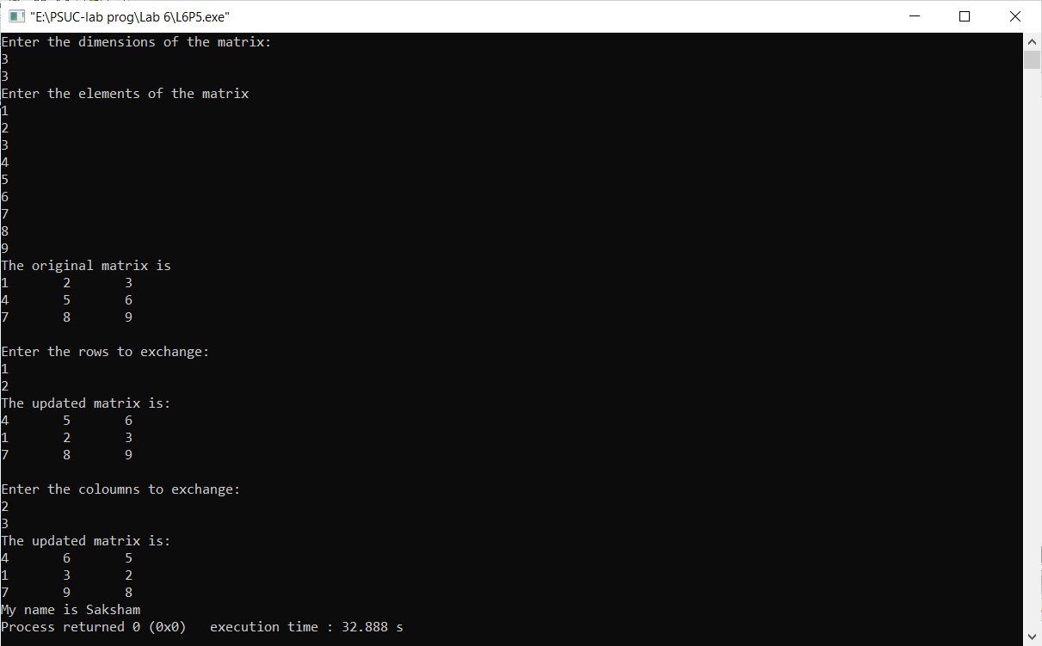

**Q5**) Search for an element in a given matrix and count the number of its occurrences.

**Code**:

#include<stdio.h>

int main()

{

int m,n,count,a[10][10],num;

int i,j;

count=0;

printf("Enter the dimensions: \n");

scanf("%d %d",&m,&n);

printf("Enter the element to be searched\n");

scanf("%d",&num);

printf("Enter the elements of the matrix\n");

for(i=0;i<m;i++)

{

for(j=0;j<n;j++)

scanf("%d",&a[i][j]);

}

printf("The given matrix is:\n");

for(i=0;i<m;i++)

{

for(j=0;j<n;j++)

printf("%d\t",a[i][j]);

printf("\n");

}

for(i=0;i<m;i++)

{

for(j=0;j<n;j++)

{

if (num==a[i][j])

count++;

}

}

if(count>0)

printf("The total number of times the element has occured is :%d\n ",count);

else

printf("Element not found\n");

printf("My name is Saksham");

return 0;

}

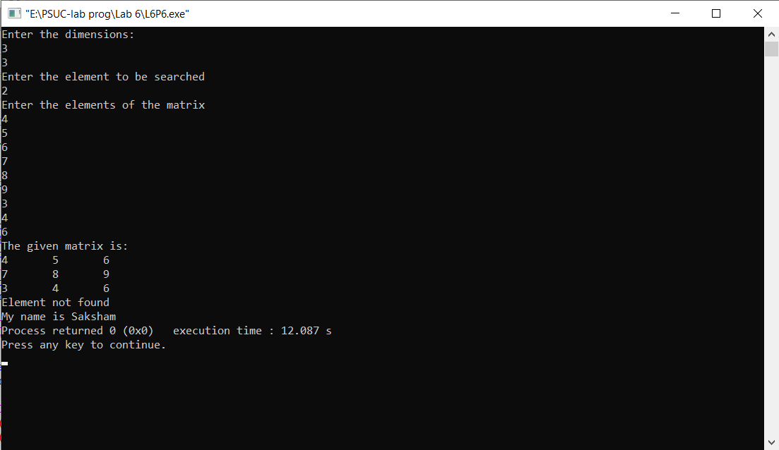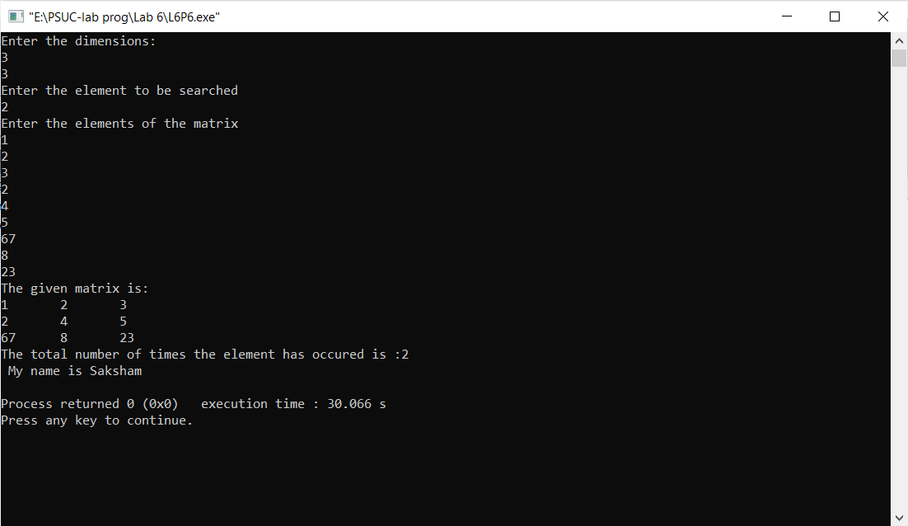**Output:**